**RNN and LSTM are sequential models**

* **RNN**

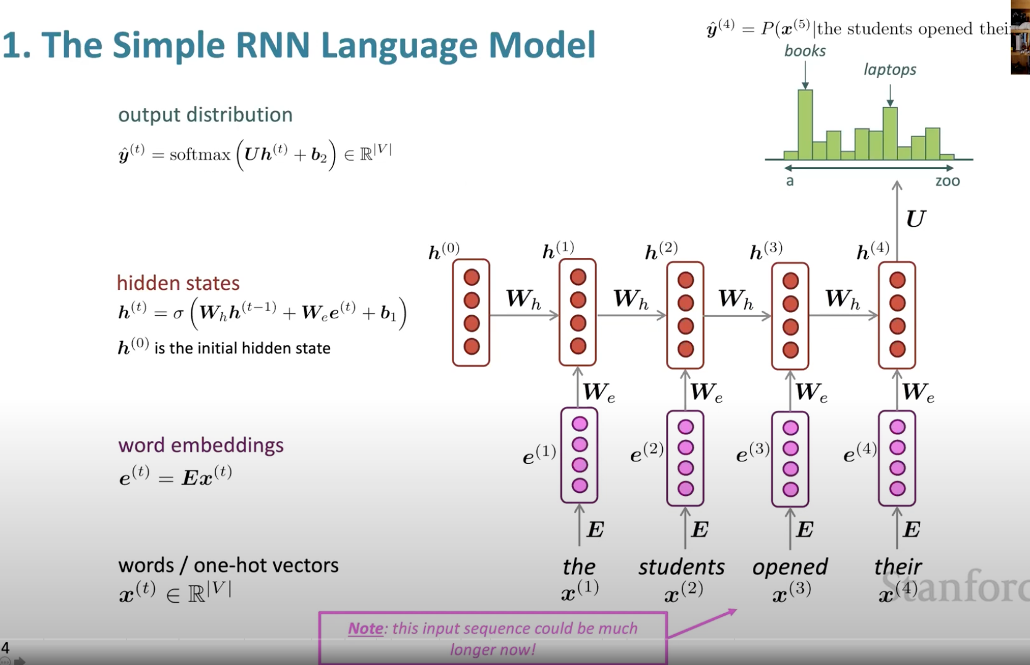

* **LSTM**

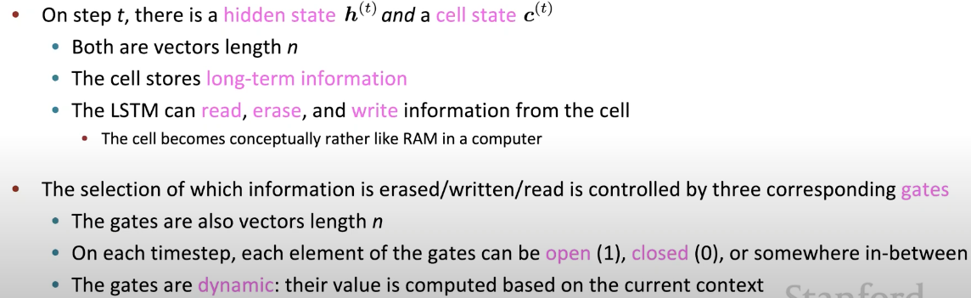

* An LSTM is similar to an RNN in that they both use hidden states to pass along information, but an LSTM also uses a cell state, which is like a long-term memory, to help deal with the issue of vanishing gradients
* An LSTM cell consists of a cell state, or long-term memory, a hidden state, or short-term memory, along with 3 gates that constantly update the relevancy of its inputs:
  + A **forget** gate, which decides which input units should be remembered and passed along. It's a tensor with values between 0 and 1.
    - If a unit has a value close to 0, the LSTM will "forget" the stored state in the previous cell state.
    - If it has a value close to 1, the LSTM will mostly remember the corresponding value.
  + An **update** gate, again a tensor containing values between 0 and 1. It decides on what information to throw away, and what new information to add.
    - When a unit in the update gate is close to 1, the value of its candidate is passed on to the hidden state.
    - When a unit in the update gate is close to 0, it's prevented from being passed onto the hidden state.
  + And an **output** gate, which decides what gets sent as the output of the time step

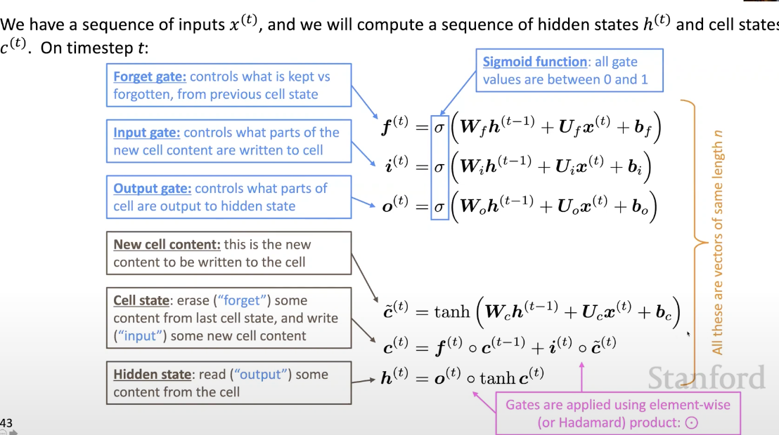

The prediction of classification for example, is **Y_pred = softmax(W_h@h_t + b_h)**

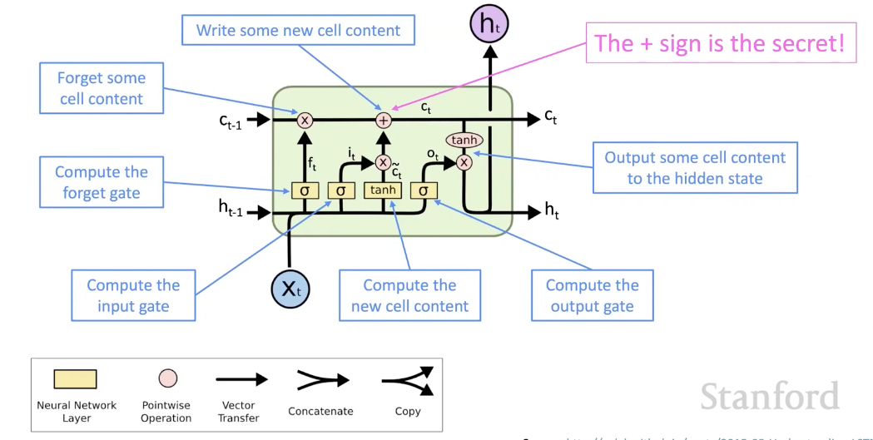

* **BIRDIRECTIONAL RNN (aka Elmo)**

In order to capture both ways of context

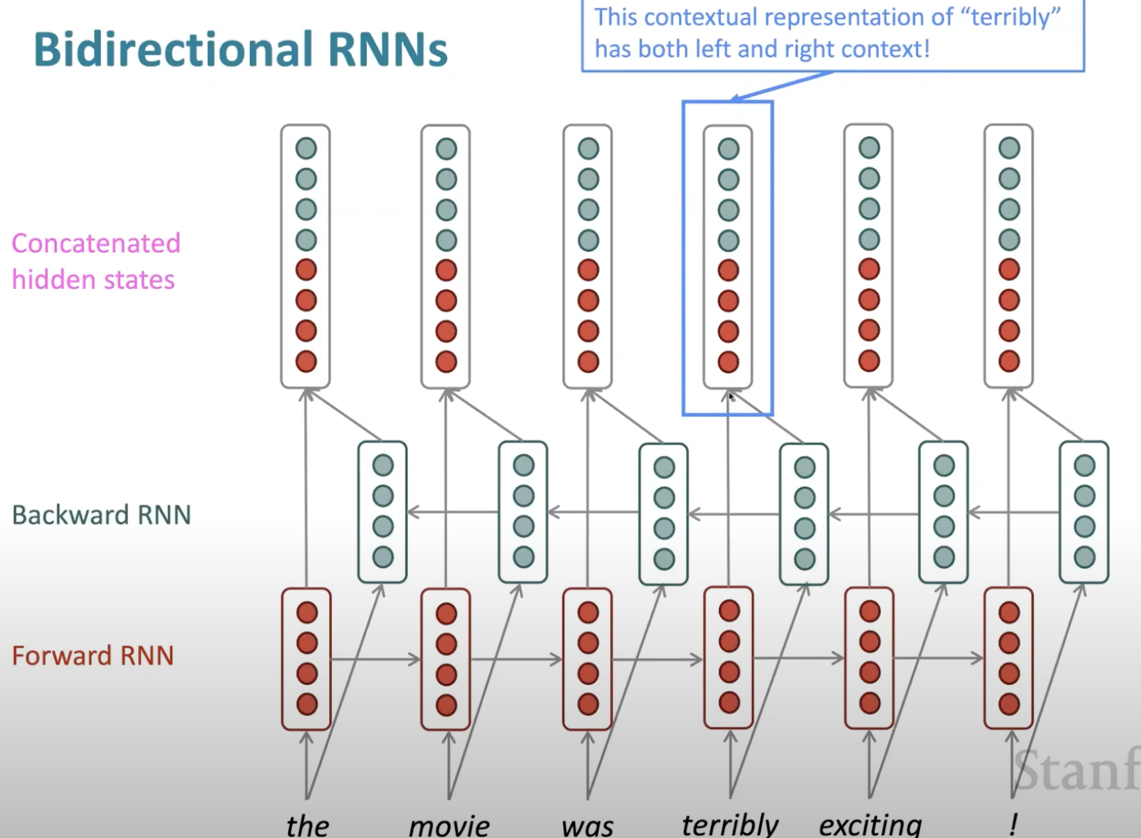

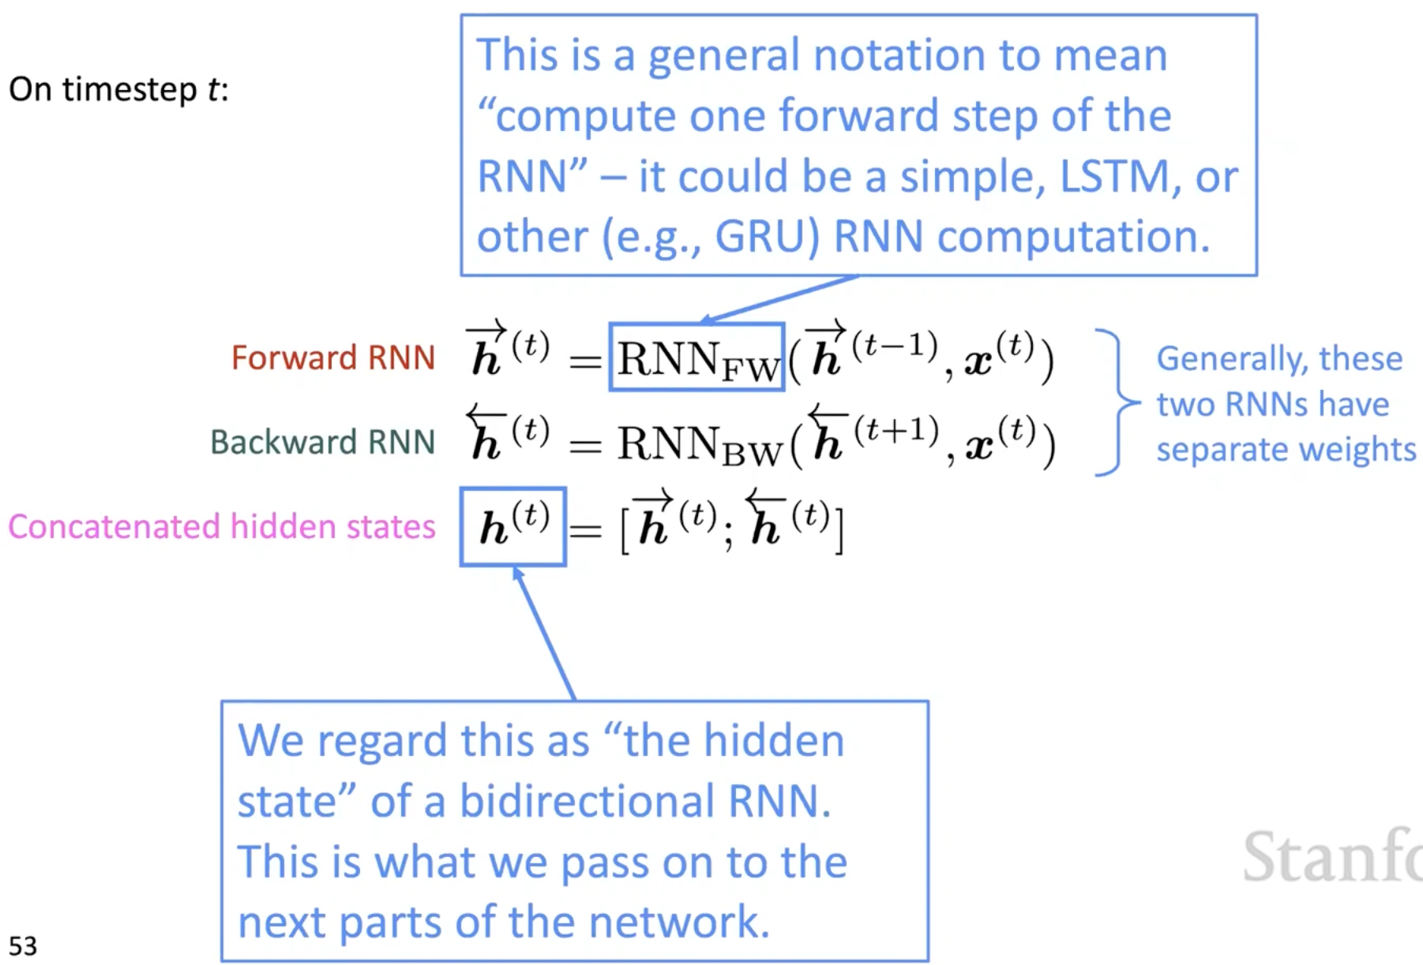

* **ENCODER DECODER**

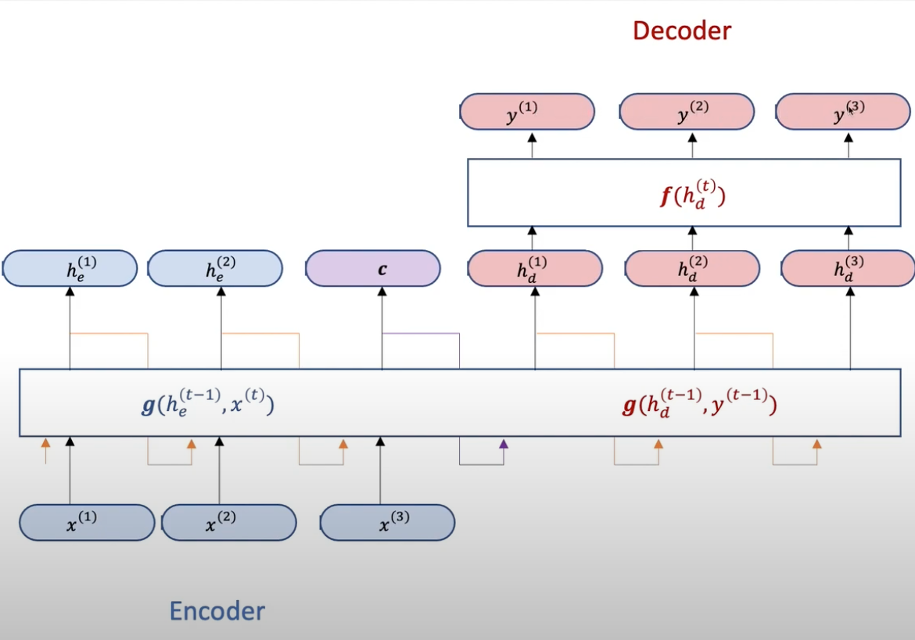

C is the final hidden state in the encoder part, which captures all the info from the previous hidden state in the sentence; the decoder takes in C as the first hidden state, and a special token (i.e `<END>`) of the previous output as the current input, CWh + <END>Wx + b to predict y(1), it unrolls C.

* **[BEAM SEARCH](https://youtu.be/wzfWHP6SXxY)** (b/c greedy search is very inefficiency)

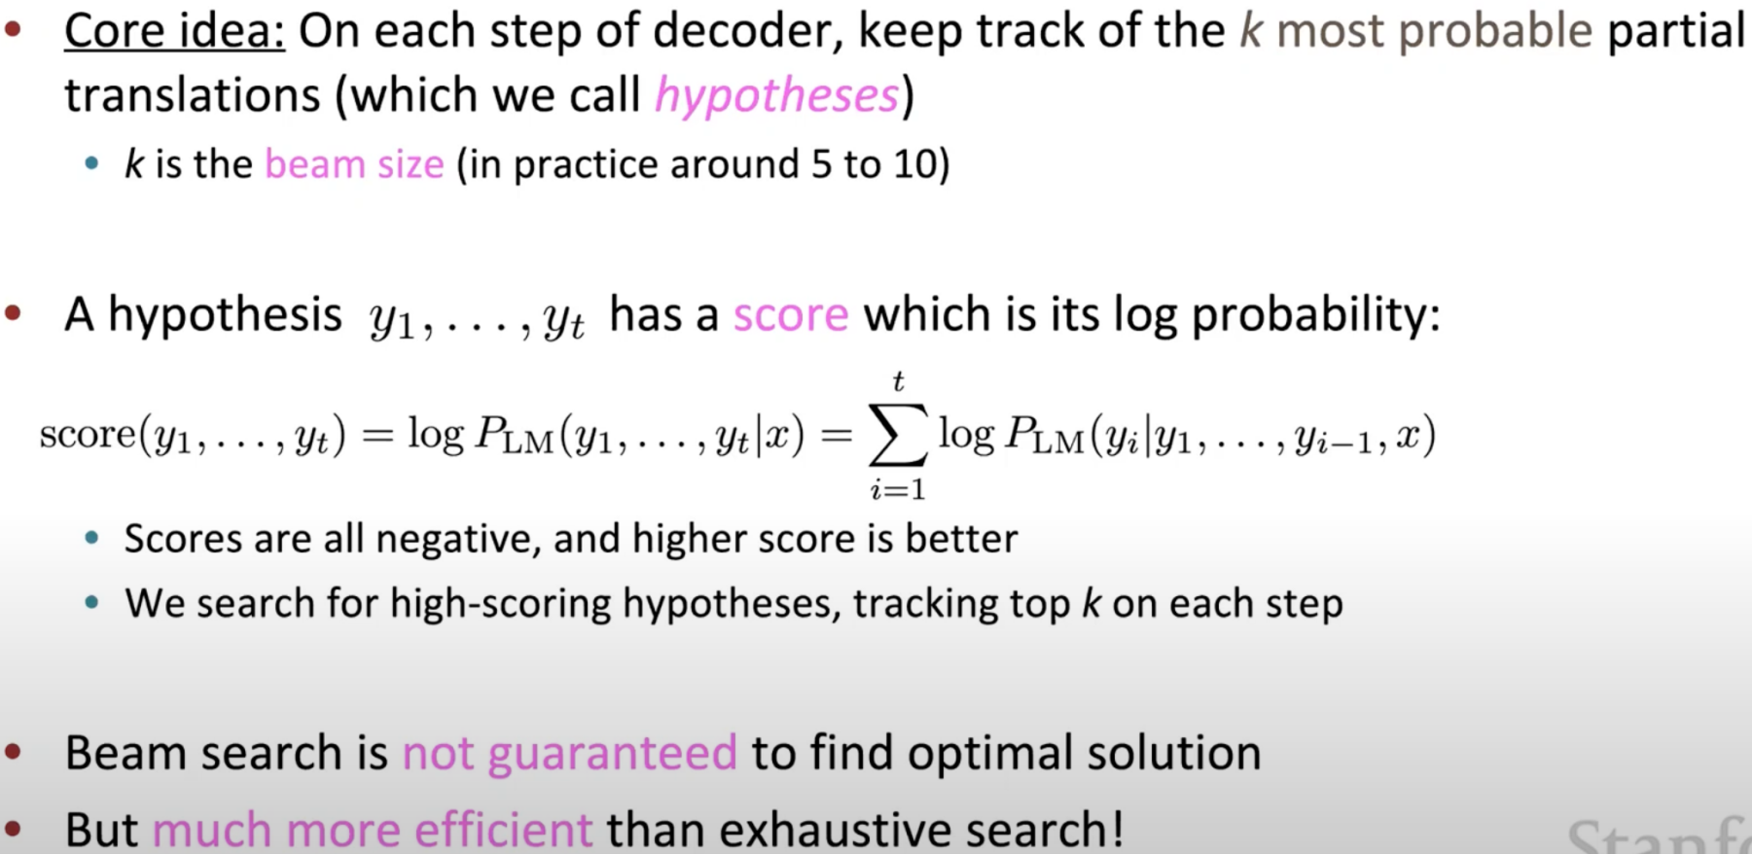

I.e., step 1, pick the top 3 words; in step 2, pick the top 3 on top of step 1, and so on. If k =1, then it becomes a greedy search

1. Stopping criterion

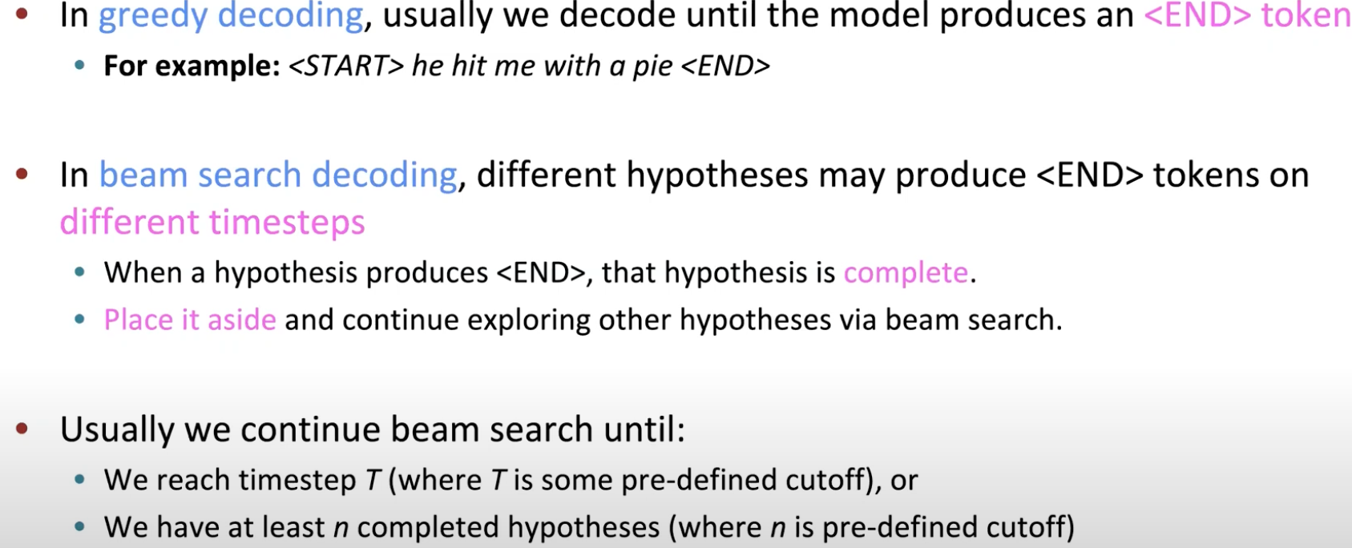

1. Problem

Longer sentences have lower scores b/c accumulated multiplication

Fix: normalize by the length. Use this to select the top one

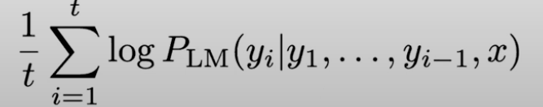

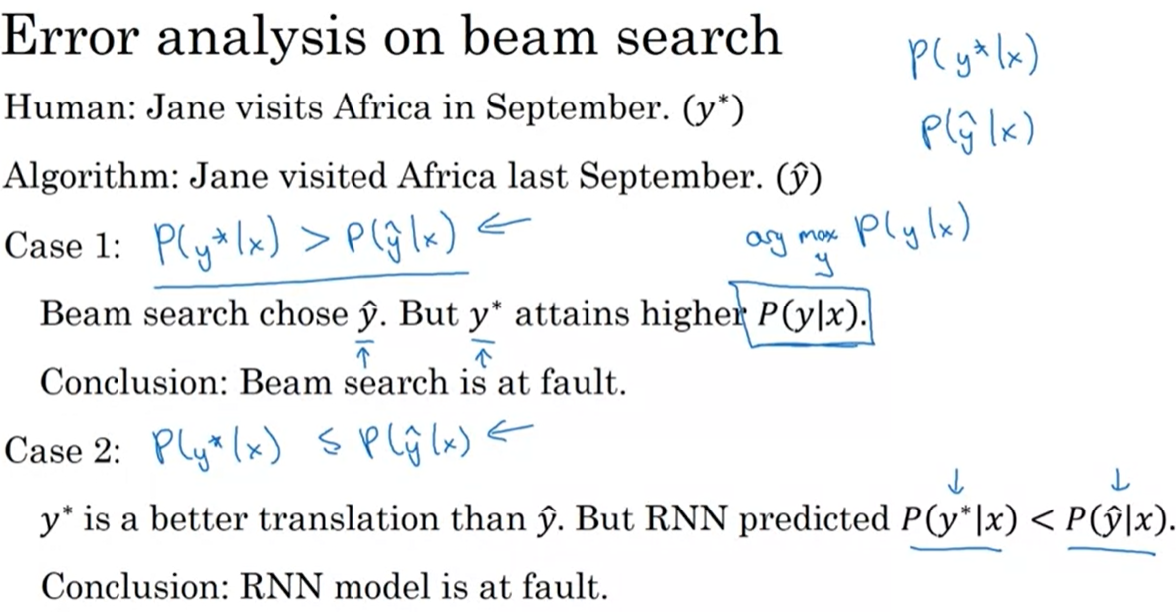

1. Bleu score (a measurement to compare multiple seq-2-seq results, i.e., translations)

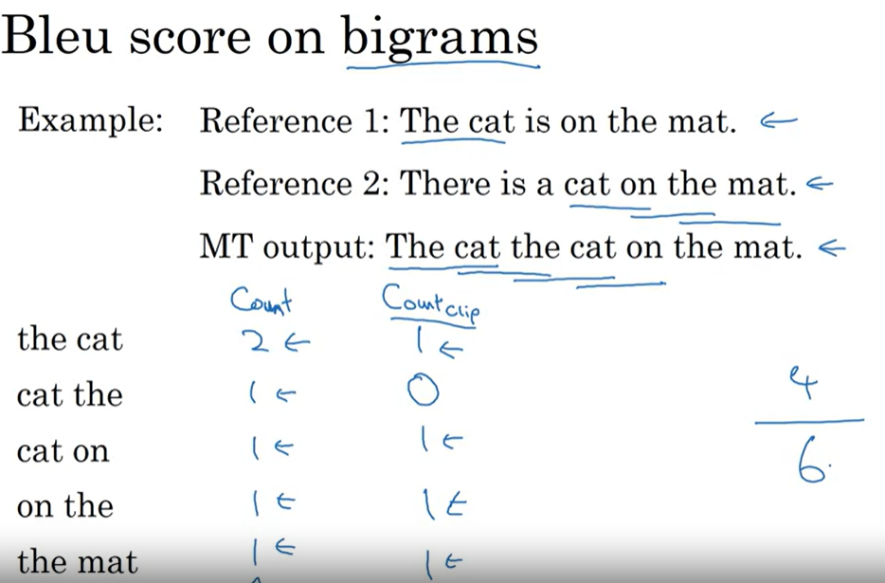

Issue: short translations tend to have a better score, to add penalize based on length:

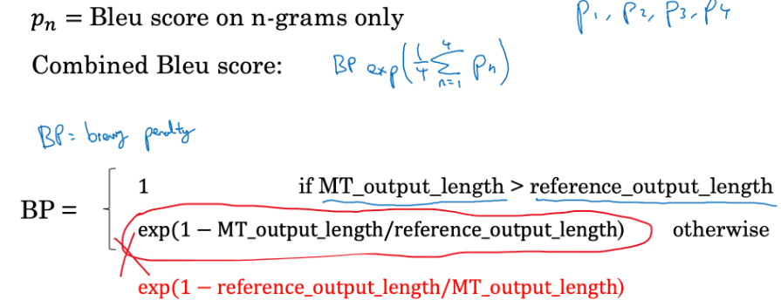

* **[ATTENTION](https://youtu.be/wzfWHP6SXxY)**

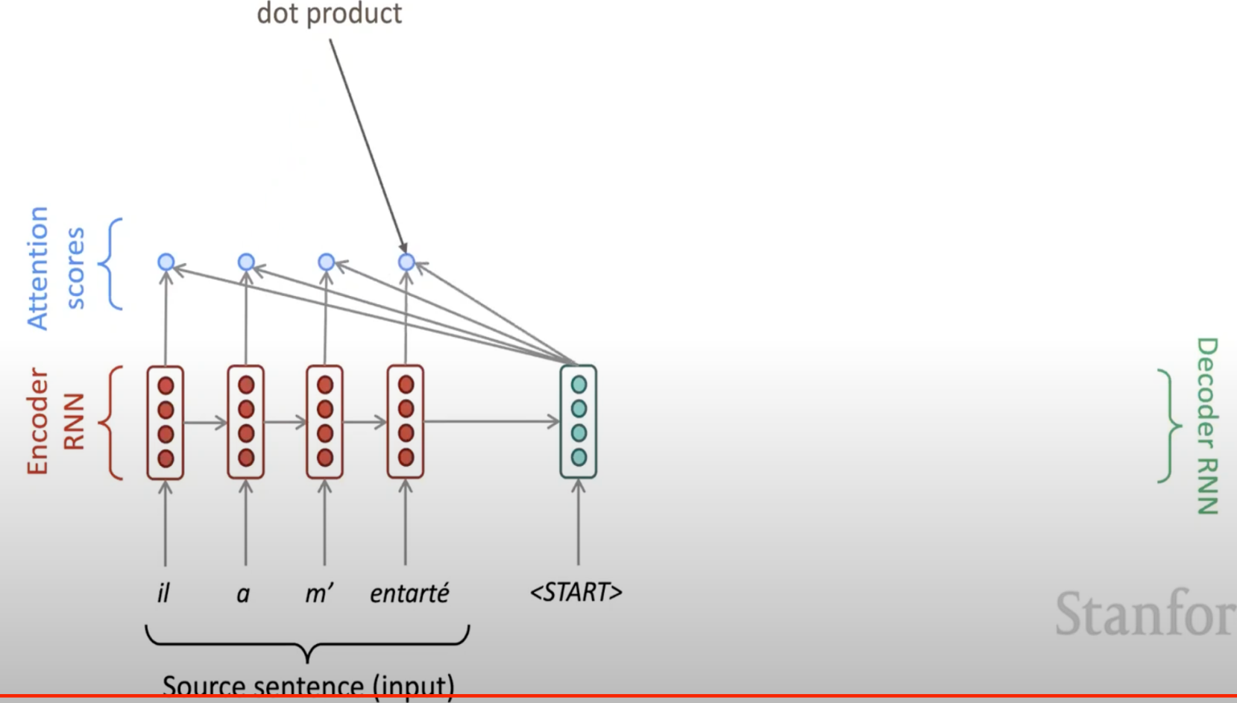

Find out which of the encoder state is most like the decoder state:

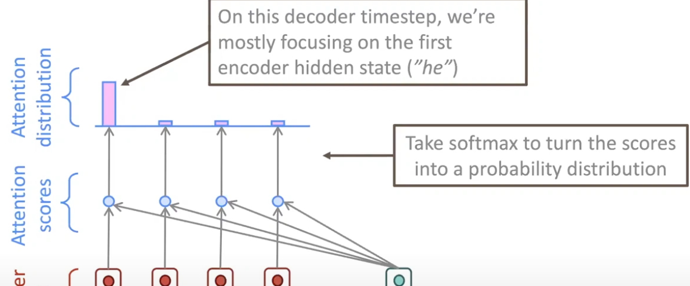

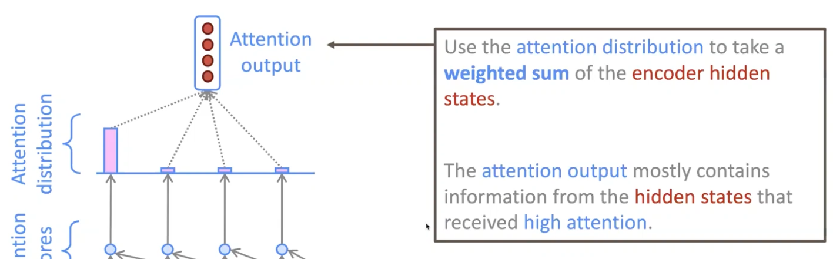

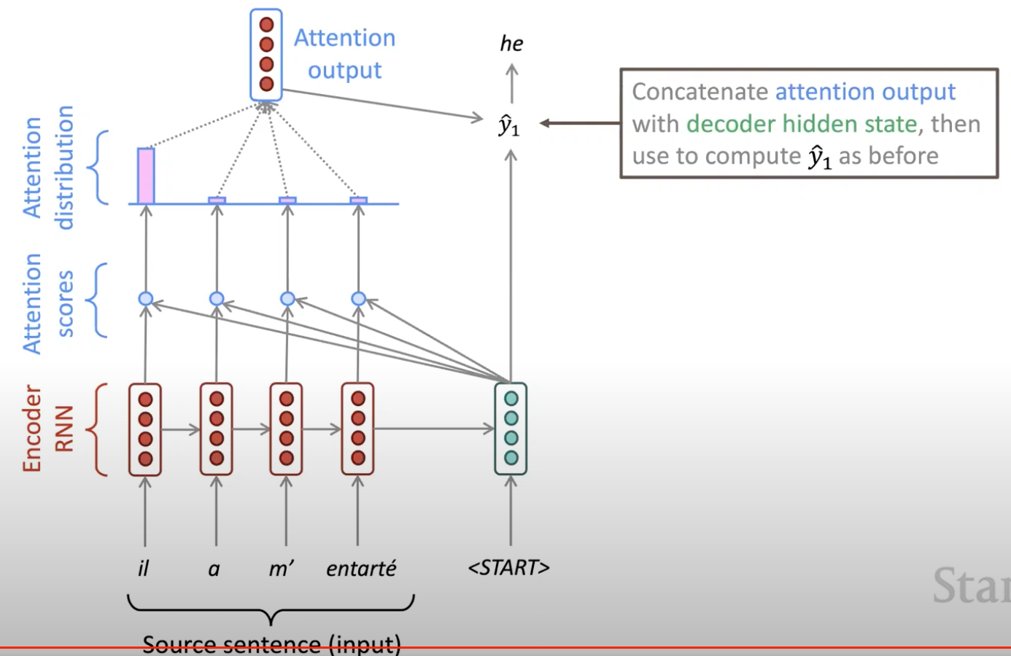

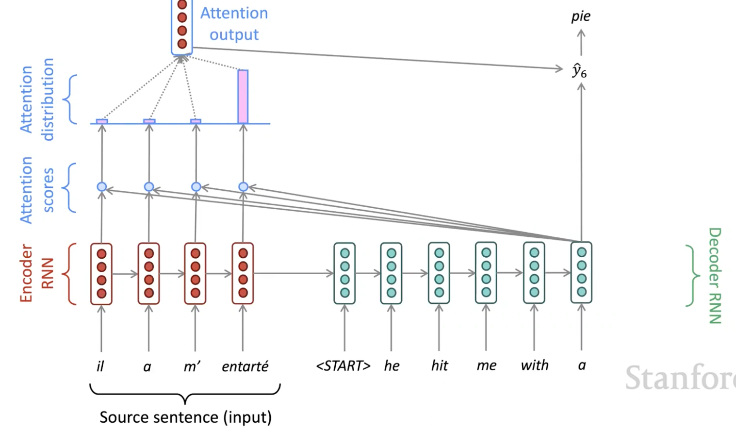

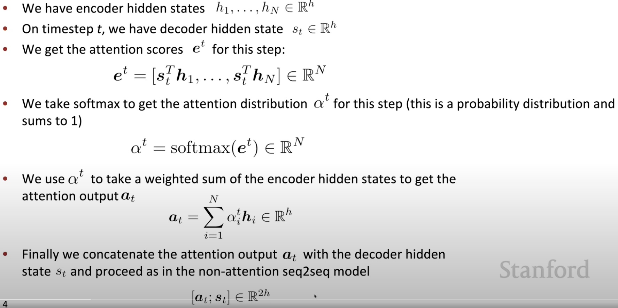

* **[TRANSFORMER](https://towardsdatascience.com/transformers-explained-visually-part-2-how-it-works-step-by-step-b49fa4a64f34)**

1. [Self-attention](https://youtu.be/ptuGllU5SQQ)

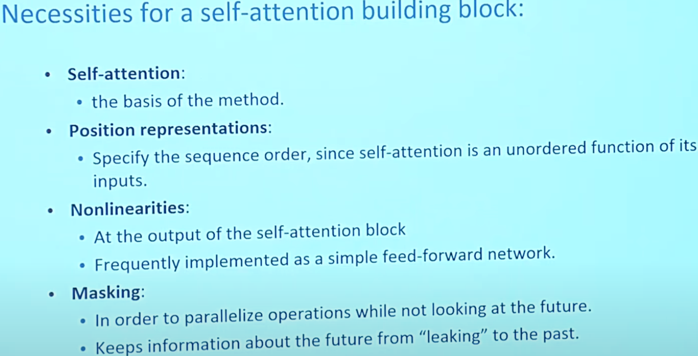

<https://towardsdatascience.com/transformers-explained-visually-not-just-how-but-why-they-work-so-well-d840bd61a9d3>

**<https://medium.com/@jinoo/a-simple-example-of-attention-masking-in-transformer-decoder-a6c66757bc7d>**

Q, K, V are formed by Wq, Wk, Wv dot with embedded input (include positional embedding)

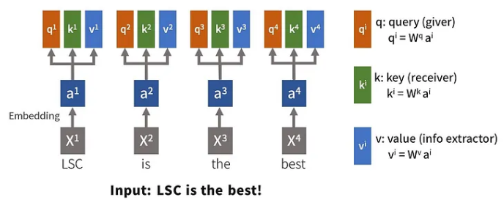

**MULTI-HEADS ATTENTION:** instead of dealing with on gigantic matrix calculation, we reduce the size of Wq, Wk, Wv, thus Q,K,V to compute attention parallelly, additionally, this can also capture semantic meaning by calculating attention score with different embeddings

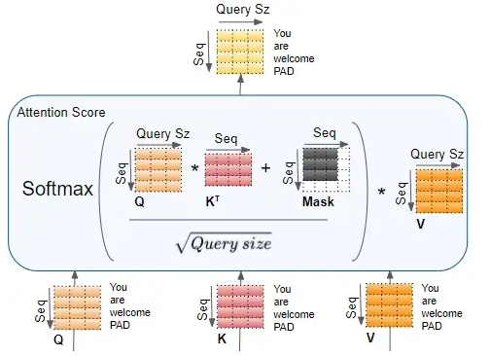

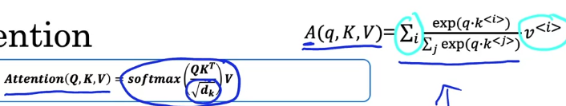

* D is the depth of k if k matrix if key shape == (..., seq_len_k, depth); scale down the dot product so that after the softmax there are enough difference to update gradient

1. **Multi-head attention breakdown**

To look at a certain word’s interactions with different positions in the sentence.

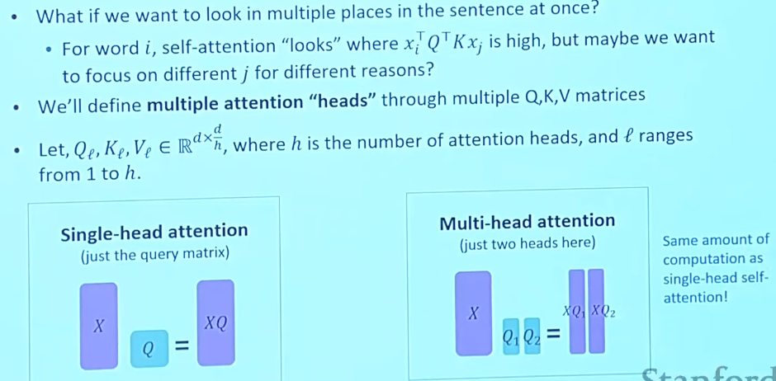

Different head has different weights for Q,K,V, they are like kernels in CNN. Computations are the same across different heads but with different weights can extract different info

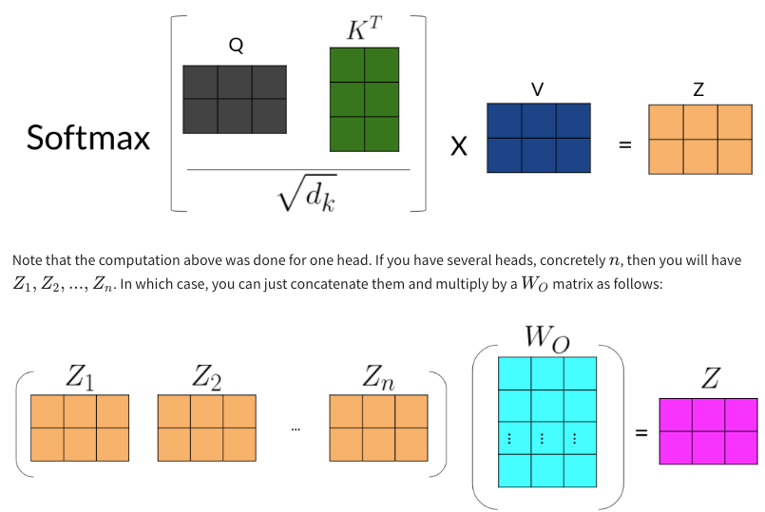

EXAMPLE 1:

a (1, 9, 512) sized input tensor, discard the batch axis, it is a (9,512) tensor. There are 8 heads of multi-heads attentions:

<https://data-science-blog.com/blog/2021/04/07/multi-head-attention-mechanism/>

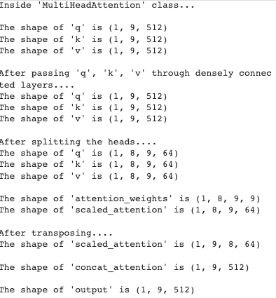

K is transposed alone the last two axis, so (K^t has a shape of (1,8,64, 9).

**Attention_weights: Q@K^t -> (1,8,9,64)@ (1,9,64,9) = (1,8,9,9)**

**Scaled_attention: Q@K^t@V = (1,8,9,9)@ (1,8,9,64) = (1,8,9,64)**

Then transpose Scaled_attention to (batch_size, seq_len, num_head, depth): **(1,9,8,64)**

**Concat_attention: concate along the num_head axis, (1, 9, 8*64) = (1,9,512)**

**Output: pass the concate_attention to a dense layer**

EXAMPLE 2: when q has a different shape than k and v, translation task

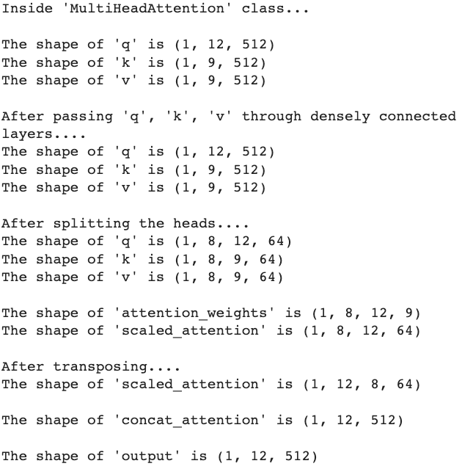

1. Architectural

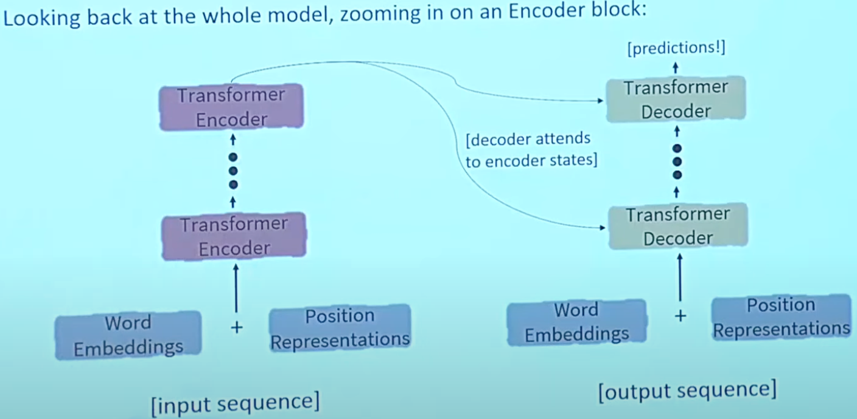

Positional encodings can affect the word embeddings, but if the relative weight of the positional encoding is small, the sum will retain the semantic meaning of the words.

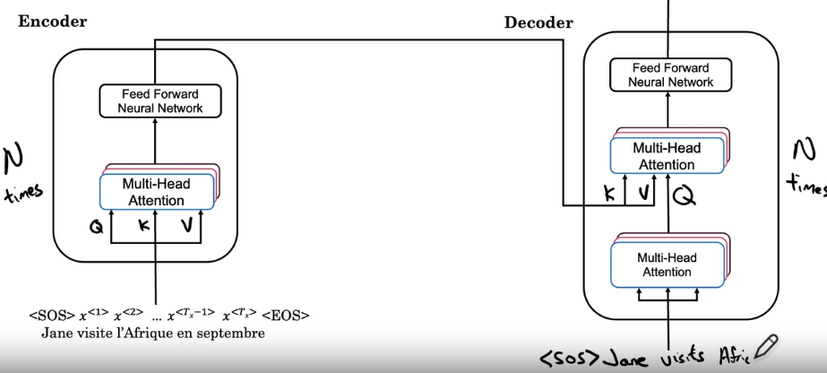

Positional embedding vs encoding: encoding is a function that transform a value to another (sin, cos); embedding is a learned lookup value.

Encoder provides k,v matrix, decoder provides q matrix. what masking does is it blocks out the last part of the sentence to mimic what the network will need to do at test time or during prediction. **Mask only happen in decoder**

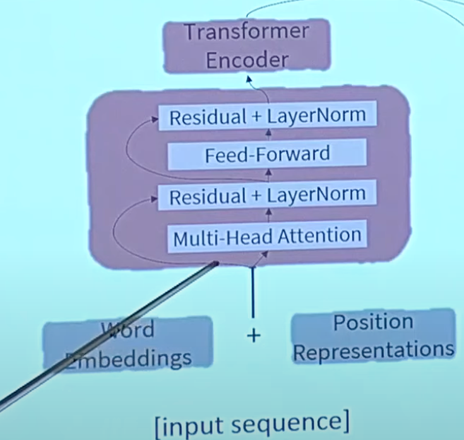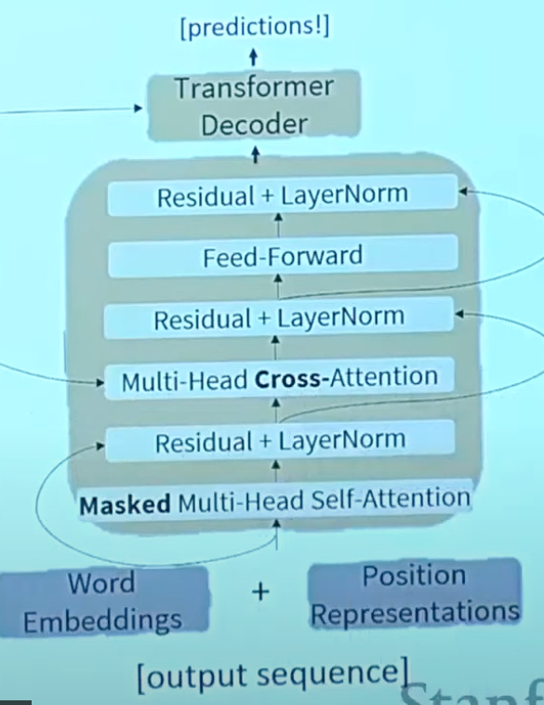

Residual connection (aka, skip connection):

applying layer normalization on sum of the input and the attention output to get the output of the multi-head attention layer

skip_x_attention = self.layernorm1(x+self_mha_output) # (batch_size, input_seq_len, fully_connected_dim)

self_mha_output is the output from multi-heads attention

* **BERT (Bidirectional Encoder** Representations from **Transformers**)

Two steps:

1. Pre-training on unlabeled data over different pre-training tasks
2. Fine tuning: Initialize with the pre-trained parameters, then fine tuning using labeled data from downstream task
3. Choose 15% of the token randomly
4. From step 1, mask 80%; replace 10% with random token; 10% keep as is

Input:

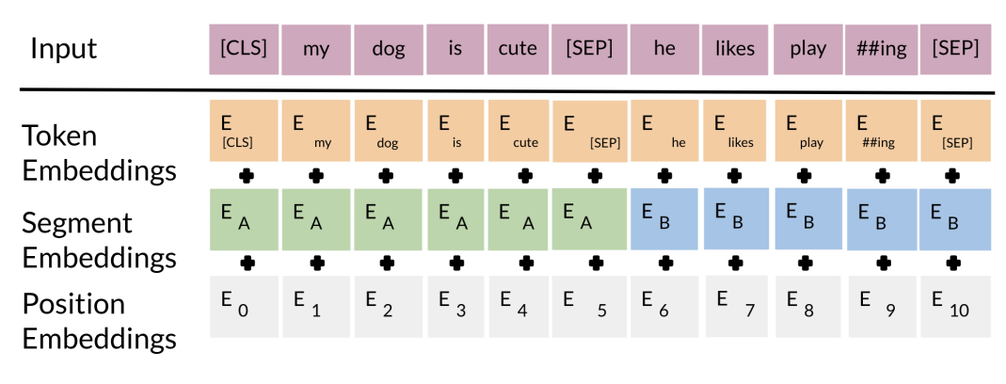

The **input embeddings** are the sum of the token embeddings, the segmentation embeddings and the position embeddings.

The **segment embeddings**: allows you to indicate whether it is sentence a or b.

**Positional embeddings**: allows you to indicate the word's position in the sentence.

Objective:

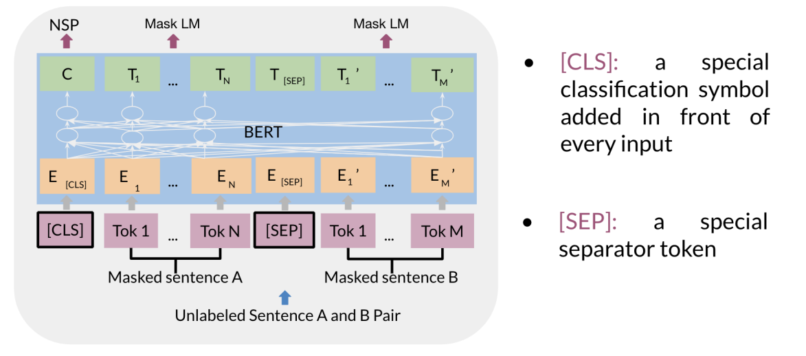

The C token in the image above could be used for classification purposes. The unlabeled sentence A/B pair will depend on what you are trying to predict, it could range from question answering to sentiment. (in which case the second sentence could be just empty). The BERT loss is the combination of each obj losses:

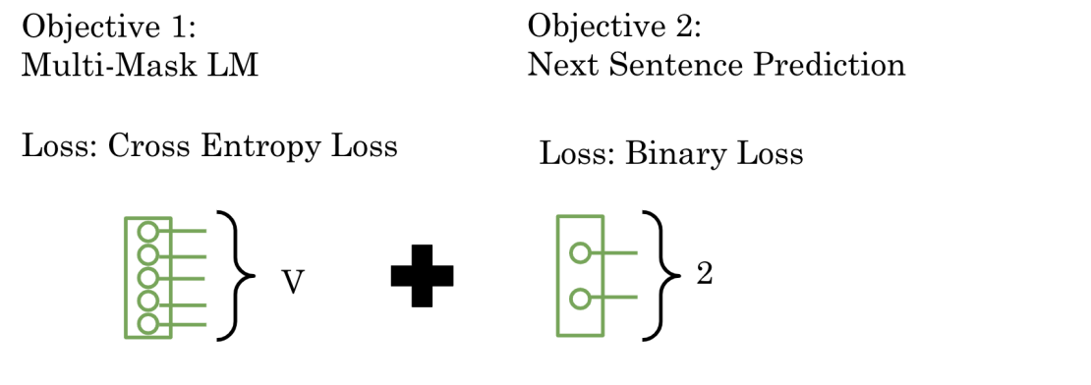

* **T5 (text2text transformer)**
* **LEARNING WORDING EMBEDDING**

**Word2vec:**

1. Skip-grams

Learning context word’s embedding by predicting randomly chosen target word (within a window)

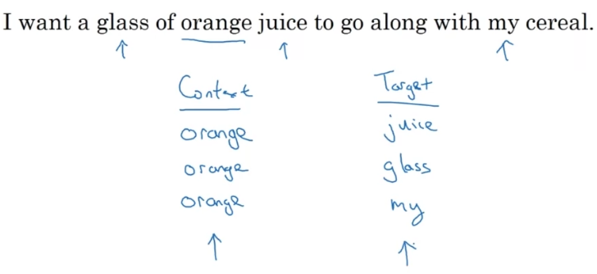

Problem: softmax needs probabilities of all the prediction first, very expensive

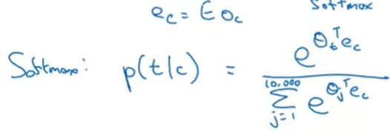

Theta_t is the parameters associate with the output t. what’s the probability t being the true label given context word

1. Cbow: using sounding few words(depends on window size) to predict the context word
2. Negative sampling

Give a pair of words, and predict if they are context-target pairs within a window(with true pair and randomly picked pairs).

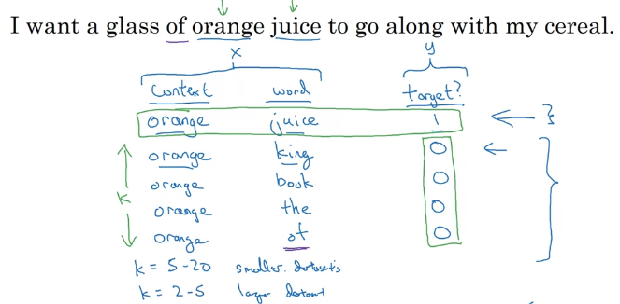

Instead of computing a softmax across the entire vocabulary, negative sampling computes binary-class classification across vocabulary, which is much cheaper

1. Glove

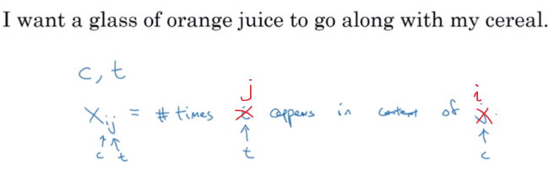

It captures how many times context and target words appear near each other (within a window size)